Visual Studio code have many great features built into it. One of the great features that been built in it is the list of the commands.

Using the short cut Ctrl + Shift + P will open up it whole list of commands

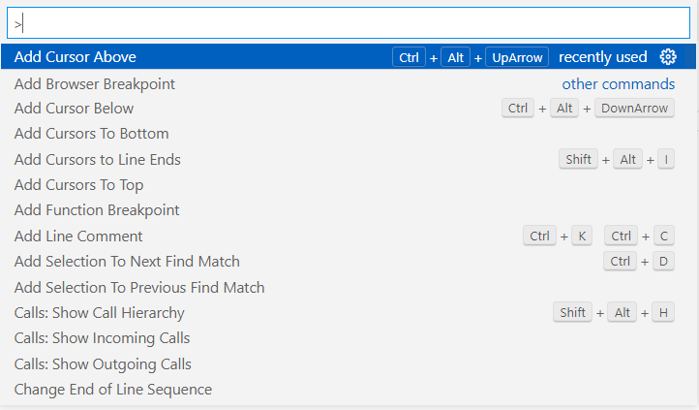

After it show the whole list of commands that can be use in the current file. The built in commands supports a lots of different programming language like JavaScript ,html ,Python and many more. To get in more commands there are many extension that added in more.

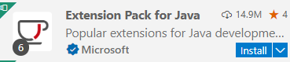This example on the left show the extension pack for Java ready to be install and use. This extension pack also includes commands for Java  
There are also ways to add in the commands in as well. By adding in vs command module into JavaScript.

Some commands might not have shortcut, some have a single key chord to activate the commands. And there are even some that have two Key cords that activate the command. Usually with the second key Cord, Visual studio code will wait for you until you press down the second key cord.



If you don’t like the shortcut the was given to activate the commands. If you click the settings that is located on the right side of the commands. It will take you to the page where you can change the shortcut yourself. You have to double click the key binding and press your own keys down. It can do up to the second key cord. After you done setting it up press enter and it will save that new shortcut.

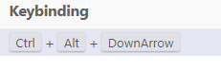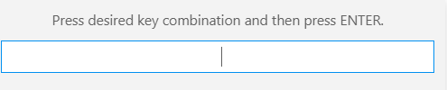

Visual Studio code also have It own Git integration built into Visual studio code. This is available in atom but as a extension. To first start up your git integration is go to the source control tab. It should be already set up to GitHub if you start up the editor in GitHub desktop

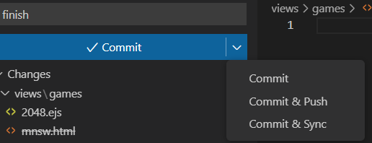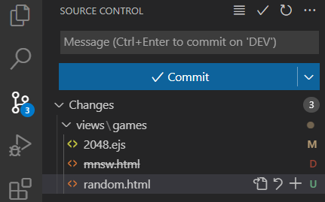The light up icon on the left side bar is the source control tab. The blue circle with the number show the amount of changes that have been made in the repository. It will also show you which folder and files that have been change. M stands for modified files that have it codes within change. The D stand for the files being removed/deleted from the repository. U stand for added in files into the repository. After everything have been reviewed and ready for commit. The first thing you must do to avoid a error is to add in a message. After you done with the message. You have three choices. Commit allows you to commit only to your desktop. Commit and push will let the commit to be public on GitHub. Commit and Sync will push and pull from GitHub repository.

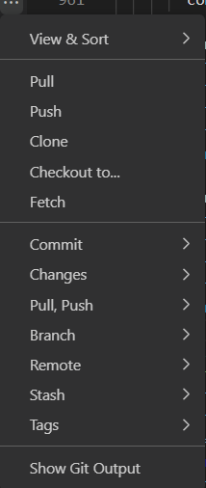There are also other options to use the git integration in visual studio code. Some or most of the option is already available in GitHub desktop. Pull with pull information from the GitHub repository. In order to grab information from the fork repository is to use the merge branch option from upstream branch to your current branch. Push will allow you to push the newish commits to your GitHub repository. You can also create new branch by using the branch option. The Git output option will show you the command line of how the git import and export information. It can also be use to found any errors that might occur. There are also a sync option which allows you to push and pull at the same time, but it safer to pull and push at different times. There are also many other GitHub extension that can improve the built in function. For example. There a extension to add in the pull request option.